Computer Science Jeroo Lab 3D – Water Hazzards Lab Value - 100

Lab Goal: This lab was designed to teach you more about using loops, ifs, and methods to solve problems. You must get comfortable with single Jeroo methods being called multiple times in solving problems that involve the same actions being repeated. This lab requires precision in making sure your Jeroo accomplishes his assigned job. You must also calculate out how many flowers are needed to complete the job.
Lab Description: Create a method to place flowers around a water hole / lake. Make another method to move around the island and find all of the unprotected water holes / lakes. Once you find an unprotected lake, call the method to place flowers around the edge and then move on to another water hole / lake.
Files Needed ::
Jeroo_Lab3d.jsc
WaterHazzards.jev

Starting Screen:

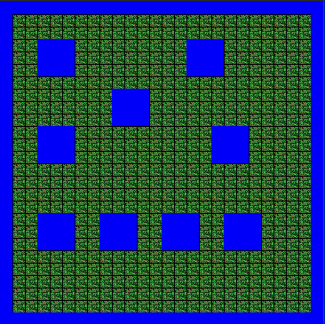
algorithm help

Preconditions –
- How many Flowers to start

Postcondition –
- Arrive at the final position
- Face the west

Hint – Can your method start from just anywhere – or does it need to be a specific position next to the water?

Ending Screen:
